**Precipitation and Water Purity**

He Wenxin何雯欣

April 3, 2019

Student ID 518370910117

Section 3

Group 3

Members Qiu Jiahao 裘嘉豪

Feng Hanyang 冯瀚扬

Xu Jiaying 许佳滢

Telephone 15921193245

Email Address wenxin_he@sjtu.edu.cn

University of Michigan-Shanghai Jiao Tong University Joint Institute(UM-SJTU JI)

# I INTRODUCTION

**A. Objectives**

* Have the knowledge of the ways to determine the identity of different precipitates.
* Find out how ion characteristics are connected with precipitation
* Figure out whether precipitation requires a minimum concentration of ions
* Compare how the difference between water and other solvents affect the water purity and precipitation.
* Design experiments to distinguish unknown ions in a solution.

**B. Background**

Chemicals in water have potential threats on water safety. For instance, soluble heavy metal ions like mercury and lead are toxic. They also affect water purity. Alkaline earth metal ions will result in water hardness especially in the presence of soap. Calcium and stearate ions will form insoluble scum. The solids formed by soluble ions combining together are called precipitates.

# In the experiment we will be asked to answer questions like: Is precipitation predictable? We will also design experiments to spot and remove certain ions by the process of precipitation.

# Ⅲ EXPERIMENTAL PROCEDURES

**Part 1 What is a Precipitate?**

1. Record the appearance of 0.1M CuSO4 solution and 0.1M BaCl2 solution.

2. Combine the solutions in a beaker and record your observations. Label the beaker properly.

3. In this reaction, ${Ba}^{2+}$ and ${SO_{4}}^{2-}$ can combine to form the precipitate.

4. Separate the solid and liquid by filtration. Record your observation of the properties of the filtrate.

5. Write the chemical equation of this reaction.

**Part 2 Is Precipitation Predictable?**

1. Make a hypothesis concerning the question “is precipitation predictable?” which relates precipitation to cation characteristic.

2. Add two drops of the cation solution from group I or II to each column of the first anion row.

3. Record your experimental results in table1.

4. Record the spectator cations and anions.

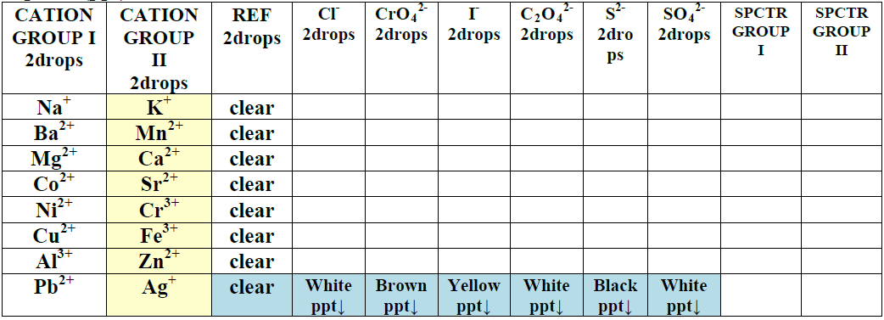

**Table 1** The record table

5. Record the properties of ions in the periodic table and see whether there is an observable pattern in the data.

**Part 3 Concentration and Precipitation**

1. Each group must select 3 types of reactions from the left column of Table 2 and carry out the experiment using the corresponding reactants in the rows of Table 2.

2. Typically the stock solutions are 1M and you have to dilute them to 0.1M&0.01M.

3. Add ten drops of the two reactants to a test tube. Shake it and record the amount of precipitate as “lots”, “slight”, “none”, or “unsure”.

4. Repeat the reaction at higher and lower ion concentration and record your observations.

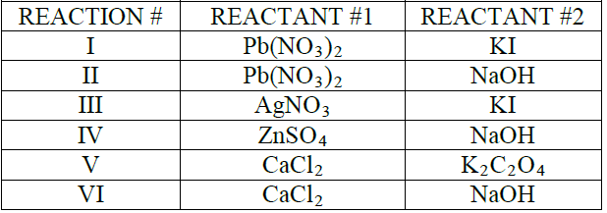

**Table 2** Reactants

**Part 4 Solvent Pollution & Precipitation**

1. Add a few reactant#1 crystals to each of the three test tubes. Then add 2mL water, hexane and acetone to the tubes respectively. Shake and record your observations. Determine whether the crystals are “insoluble”, “slightly soluble” or “soluble”.

2. Repeat the tests with reactant#2.

3. Take the supernatant liquid into clean and dry test tubes.

4. Mix the supernatant liquid of reactant#1 and reactant#2, observe whether there are any precipitates.

**Part 5 Can I purify it?**

Design a method to remove Cu2+ from the water sample as much as possible. You can use any of the reagents mentioned in this experiment.

**Ⅸ REFERENCES**

-1. Peter Atkins, *Chemical Principles The Quest for Insight Seventh Edition*, Macmillan education, 2016.

-2. VC211 Laboratory Manual, UM-SJTU JI &SJTU Chemistry Department, 2018-2019.